Reiki 2 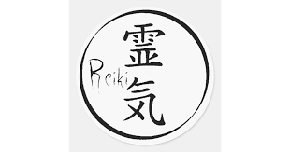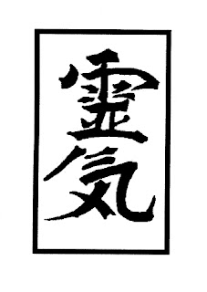

Handbook

Reiki 2 is second degree of Reiki system. In this book you
will find all techniques of Reiki 2 degree. Thirst of all Reiki is light and blessing of light. Reiki can forgive sin and sins. Reiki is light (prana) going through your hands that you now from Reiki first degree. Reiki Usui Ryoho system had 5
Symbols of all. But that simbols have working you mast have Attunement to Reiki 2 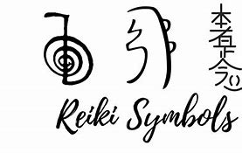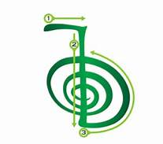1. The Symbol (Name of the 1.(first) Reiki 2 Usui Ryoho the Symbol is (Cho Ku Rey) it is (the mantra of the Symbol as well) .

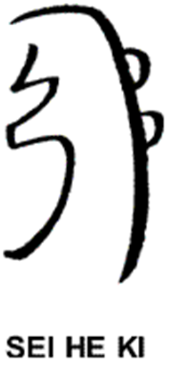
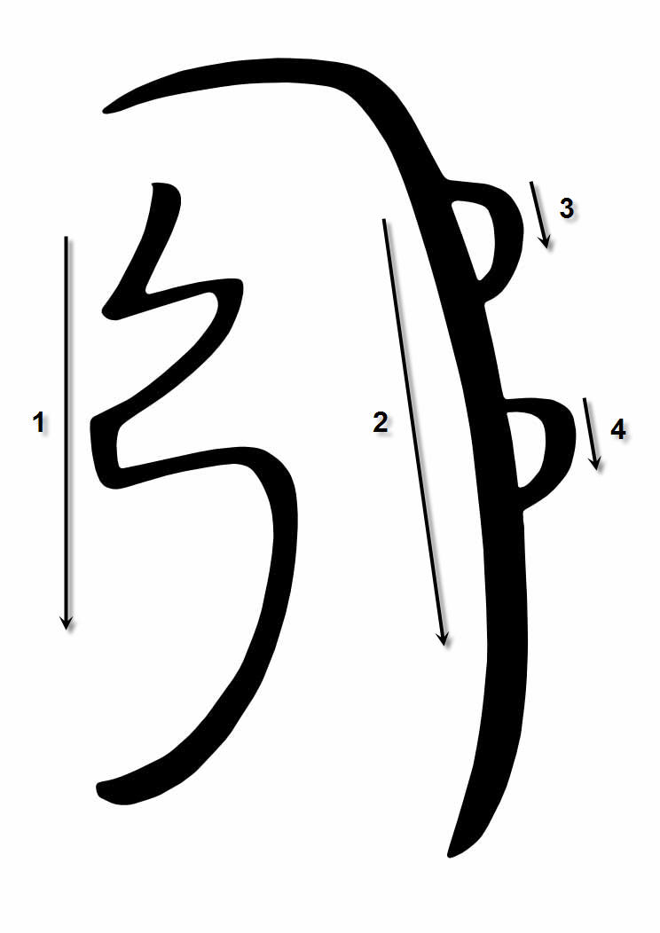
The Symbol 2 (upstairs). Name of the symbol
is (Sei He Ky) and it is mantra as well of the Symbol.
Symbol 3.
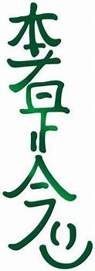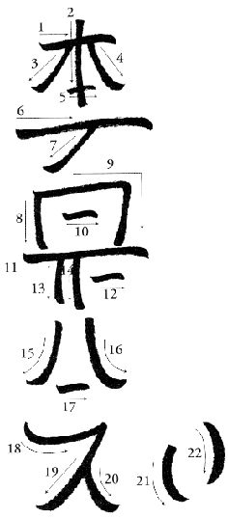
The name of the Symbol is (Houm Sra Sro Nama)or another one(Hon Sha Ze Sho Nen) and The mantra of the Symbol is (Houm Sra Sro Nama).
Remember these symbols.
It,s takes some time to remember them don’t worry
Reiki will take care of that.
These The Symbols are healable, after second Reiki 2 Usui Ryoho attunement which you getting now you will be attuned to them realizing.
4.The Symbol 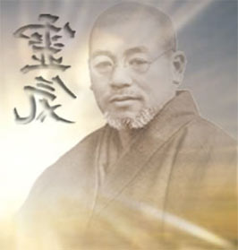
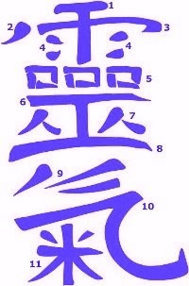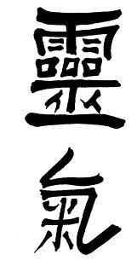
Thys The Symbol is 5 you had learned it one months ago in Reiki one. These 5 Symbols are holy. If you drawing wham not write in the beginning don’t worry becose the drawing of them is the art which you should learn Reiki will take care of that. After Usui ryoho Reiki 2 initiation (attunement) when you drawing these 4 symbols not correct they are still good. Every not write drowned the Symbol is still good and correct. They have healing powers and are holy.
If you wish to do Reiki 2 Usui Ryoho healing seasion just write on your palms with energy (energy of Reiki going out of your hands after your Reiki is turned on The Symbols by liliness (4.1,3.1,2.1,1.1) and sit comfortable.
It,s is thing like Reiki intentions it is thing of your desire (inside Reiki healing seasion) just your thingfull intention in Reiki usui ryoho 2 treatment (inside the Treatment (healing seasion) used only )(Intentions).
1.The Symbol is power Symbol. Some people is seeing inside him like The Holy Kryst with Rose on It.
2.The Symbol is (emotional, mental healing symbol). It is in void station(in the beginning-while you don,t draw him with Reiki energy going from your palms is Holy Kryst with 2 Roses it is there you will realize that than you take start healing with Reiki 2 techniques.
3.The Symbol is Distant healing symbol. It is In another words 3 Holy Krysts with the 3 Roses. Some peoples see them like that.
In all Reiki learnings you must be with Holy Kryst. If you don,t have It. Bay it or make it your self.
Reiki seasion in Reiki healing system Usui Ryoho 2
Draw the Symbols With energy going from your hands after Reiki one accomplish In Lilines 4.1.3.1.2.1.1.1 you must feel your self when you are ready for it. End when you do that relax enjoy heal end learn.
3. Is as well knowable as Reiki telepathic symbol.
Reiki telepathic and Bio sen technic of Reiki draw symbols (4.1.3.1.2.1.) with Reiki turned on (energy trobing trouth) on your palms and with Reiki energy circulated troth your hands write them on your palms. Then put them together and hold, relax (healing is processing).
It was healing.
3.
Symbol will teach you for Reiki degnostic and telepathy then you wish that. And if you wish that just learn first to scan with your hands your biofield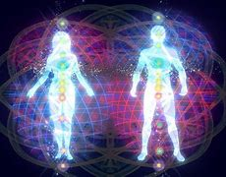. Just with Reiki on touch your energy body end where you feel hurt, or cold is needed for Reiki healing with yours permision. Just hold there your hands with Reiki turned on and Biofield will absorb the energy and will start shining bryther. As thel you can drow there 2,after 1. after them drown biofield emedetely is fixt if Reiki wish that but usually It wish. Same with all energy fields, bio, emocional, mental, Couzalic, and Spiritual. Reiki is energetic surgery with Spiritual giddiness 3 Symbol is teaching for that then you meditating on him. But to realize the symbols yours ego super ego and individual must be illuminated (not Illuminate the Ufo), but illuminated in other words you must be Enlightened.
Reiki Initiations do that, but ego and super ego and super super ego to erase it, s take time. If you are not Enlightened Reiki practitioner do Reiki 1 degree seasions still yours The Ego, The Super Ego, and The Super super ego, to iliuminate. It don’t means you cant meditate on the symbols do that. Hope you will do that it doze iliumination of ego ,Super ego,Super super ego as well.
For you techyk of Iliumination of Ugly ego, Super ego ,Super Super ego, and Super Super Super ego. Do the bracelet or the ring for your self with Reiki help. Technik; Turn Reiki on, draw the Symbols of Reiki 4.1.3.1.2.1.1.1. on your palms with Reiki energy after you already feel the Reiki energy after Reiki one healings. Put your palms together and tell in yours head, mind (Reiki please I want Reiki Bracelet of healing and you will get bracelet if you have one on you. You will fell Reiki winding through bracelet, and it means it ready you already have one. Do scanning with Reiki Telepathy Technik. Turn Reiki On and write symbols with yours Reiki on your palms 4.1.3.1.2.1.1.1. then put hand together and wait while you feel healing then hands front to front each anteater and tell in your mind(Please Reiki do I have healthy Biofield? Egz.) and scan with hands if you feel Spiritual lowly heat in front on front each other you It means -yes-. Or if Hurts it means -no-. To get correct answers you must be fully healthfully in another words you must be without the illnesses for that use Reiki one. Higher white powers waiting for you to take Reiki attunements much as possible rapt them. If you are sic you don’t get proper Reiki Diagnostic and Telepathy answers. That’s why do Reiki one healing seasions while you be fully healthy and energized with Reiki litgtht (energy).Then you are all healthy you can only then begin Reiki Usui Ryoho 2 Healing seasionns second Reiki degryy(Reiki 2) only then. If you have home printer Print Reiki Holy Krysts Symbols (4.3.2.1.the symbols with the printer) and hold them with you (they will help you to grow in Reiki) you can Print Reiki Symbols put on you on hurt place or the problem place it,s one of the ways to improve healthiness while you waiting Reiki 2 Usui Ryoho healing seasions. Keep the printed Symbols on you and then feel how you taking the healing while you taking my receipt of Reiki. Keep Reiki Symbols on you, with you, in your house. And don,t throw them out!!! They These your printed lists of papers with the Symbols good all the time. It,s sin to trough them out but Reiki forgiving sins. Don,t forget to keep with you Holy Kryst as well. Hold with you Holy Krysts much as possible if you don,t have maney make yourself.
Reiki praying from 10 years ago from Reiki world:-I am shouoing my respect for Reiki flame of white light. Reiki forgives you your sins. Soul is Godfull Goddfull have the Holy Kryst him protects you from (.) Leave all intoxications them making in your brain the dark lichuide on all brayn wolls made of toxics which don,t allow your Reiki Laight flow in your being properly . Porn is trobing out the Energy of Reiki out of you then that energy in the body is needed for healing. Porn can make you sic. Have the Holy Kryst and protect yourself. The Holy Cryst is assisting you in Reiki seasions have him and sleep with him. Then you drawing the Reiki symbols on food food schanging the taste and becomes more healther and losing the dark becoming laigther. Take e shower every day. Draw the 1. Symbol on the boiler with water and then take e shover. In the shower don,t take out Holy kryst!!! In Byble is said:
-If you have much arising the peoples which want that much and starting to want that much. That’s way God Jezis Cryst Mesi sed in own Byble give everything to poor end go to spred Byble his (Teaching) . And there is sed in Byble - book of Wisdom inside the Byble:- Wisdom is your Best Friend…!! Have the Holy Kryst with Jesus Cryst Mesi on it. Holy Kryst protects you from dark forces of dark. Every day wash your mouth with tooth brusher with Reiki 1. Symbol drown on it. And with same brusher clean your tong( same tooth brushers have on another side functionality with function of this. Or do that with same side if you wish if your tooth brusher don,t have these functionality. You must heal yourself Reiki heals the Soul in 2 degree but when you with Holy cryst with Jesis Cryst Mesi on it. In Bible sed: -That you can heal owers and yourself, then you placing your hands downwards palms up like that doing peoples in Jesys Cryst Mesi Churches. Reiki initiation just improving that capability connecting you with Divine Sours of Energing, healing white ligtht of Jesis Cryst Mesi Cryst in Reiki Usui Ryoho one Jesys Cryst Mesi healing system first you should be heald using Reiki system. Kryst have inside strong healing powers Kryst holy giomethry Jesys Cryst Mesi Statue are alive you will discover that in Reiki 2 or read The Holy Katekizm, when you was little you got negativity Reiki heals that in Reiki 2. Is there The Biggest Holy Church Katekizm you should get one becose these small is just of That big one.
Your soul is Holy. Reiki can heal bad habits it’s slowly and findfull process. After Reiki Initiation yours healing powers increases many times. Reiki healing space cleaning, energizing. Turn Reiki on draw on your palm Holy Reiki Symbols and take them toghether 4.1.3.1.2.1. (linege like was meant upwards drow them with Reiki energy after you attuned you can do that). And wait for White forces of Jesis Cryst Mesi to assist you. Some times Reiki showing you something Reiki diagnostic can came spontaneously because Reiki have Spiritual giddiness yararh on top is Jesis Cryst Mesi. You just turning degnosis in past. Another name of 3. Reiki Symbol is There is no past no Future.
It,s the old anderstanding of Reiki 3. Symbol and he is still well.
There is no beginning no end.
He is connecting you to Akachic cronics it,s is in Mountains in Himalaes In Shambala anather words in Another words He connecting you to Holy Jesis Cryst Mesi Kryst. Cho Ku Rei translaited from Sanscrit is: -Holy Cryst with Rose on you with Cryst Mesi on you I am showing my respect for you and Kryst of Cryst respect showing bowing for you Jesis Cryst Mesi and God respect, respect for all divine white laigtht of your Holy cryst-. Sei He Ki Transleited from sanscrit is the: My bllessings for Holy Cryst of Holy Cryst with 2 holy Roses and bowing for Jesys Cryst Mesy Sun of God and deep boul for Holy Cryst and his Kryst. P.S. Trouth this Praying you connecting to your Haigther self and through him you healing your Holy Psihic. That’s why 2. is emocional and mental. Third simbol is mantra Houm Sra Sro Nama the translation is from Sanskrit- Holy Cryst with 3 Roses on you and Cryst I Am boing for you showing my respect for you I am gone in Mesi Jesis Cryst Cryst I am bowing for Him and his Kryst.
Your linege of Reiki is Mesi Jesis Cryst Sun of God.
You are god, you are Perfection of Jesis Cryst Conciuossness. Get the Holy Bible it gives you protection as well. God temple is in you sed;- in Holy Bible. So do the Cleaning in the temple of you.
I am sending for you Reiki healing and bllesings wish for you heists results in yours Reiki 2 practice.
In Reiki 2 you can heal The root of the problem. Haieists bllesings for you. With 3. The symbol you are connecting with the Holy spirit, and Cities of laigtht of Reiki.

Have fun and enjoy yours healing.
Reiki 2 you can heal anything you want.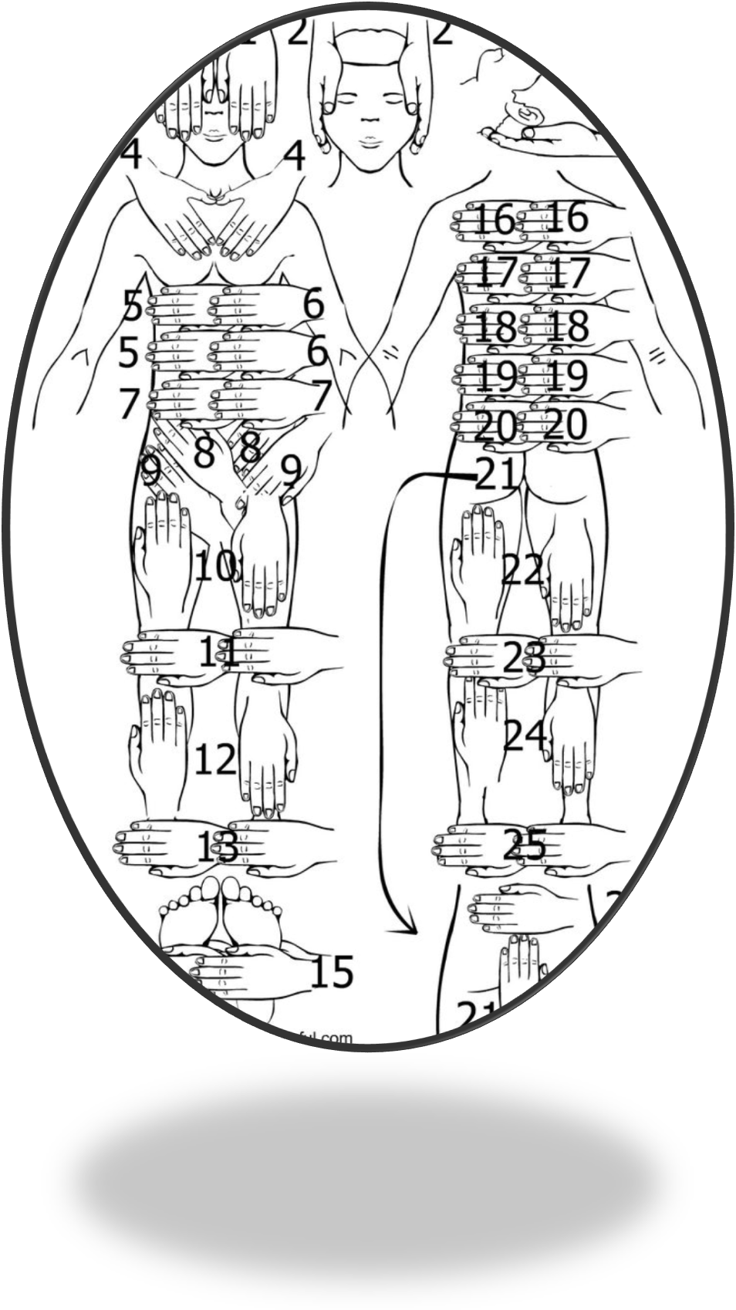
Thank you for picture Reiki master. In Reiki 1.2. you heal the 5 elements easy to.

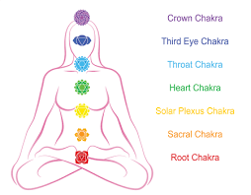
Thigh Reiki 2 and Holy Kryst I healed 9 my not healebale deasyses. You will not be forget Reiki will help you . Reiki will show you the way to
Holy Kingdom of Reiki laight.
Then I do Reiki seasions I do fell the worm heating, tingling on different places of body pacientts fell the same, Reiki is holistic healing. Sometimes cold waves then becoming hot for my These cold feelings is arising because Reiki energy frequency is hither then body energy(prana which is circulating with your breathing ritm)Then you are breathing you are breathing energy. And Reiki just balancing these 5 pranas(energies)-sweet cold, sweet warm, sweet hot with tingling, little hot with tingling and super cold. In sanscrit translation prana is energy Prana ,apana, udana, samana, uyana.(wayus Sanskrit;- wind(energy) Soul is the size of entire body she is protecting all body and are swimming in these pranas:-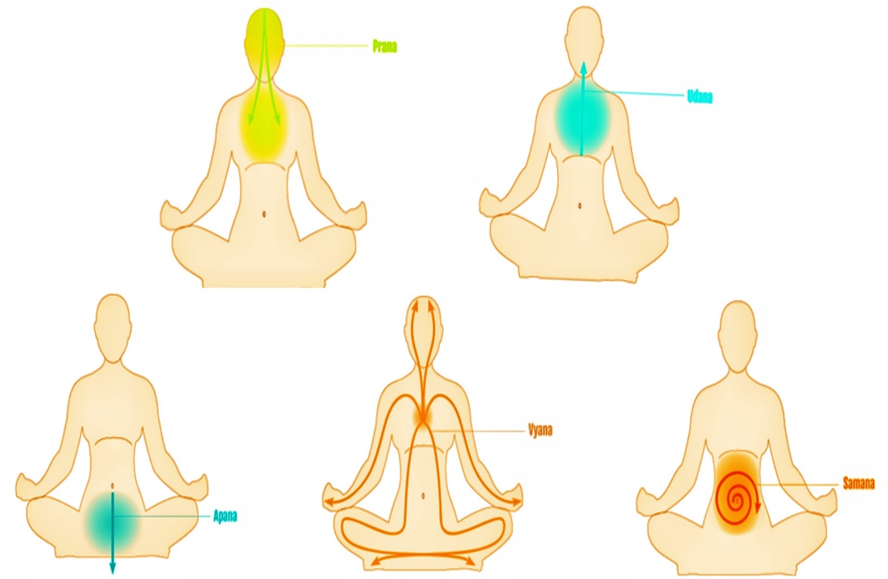
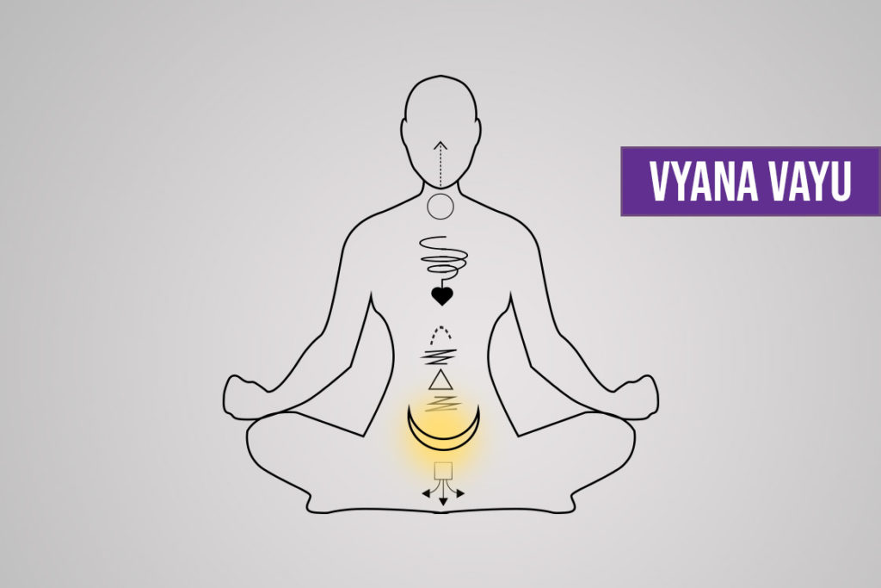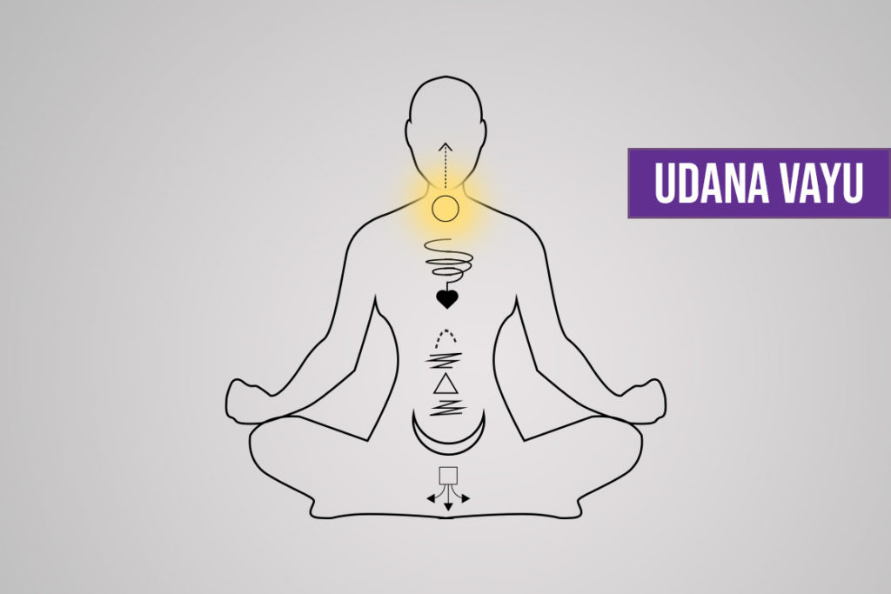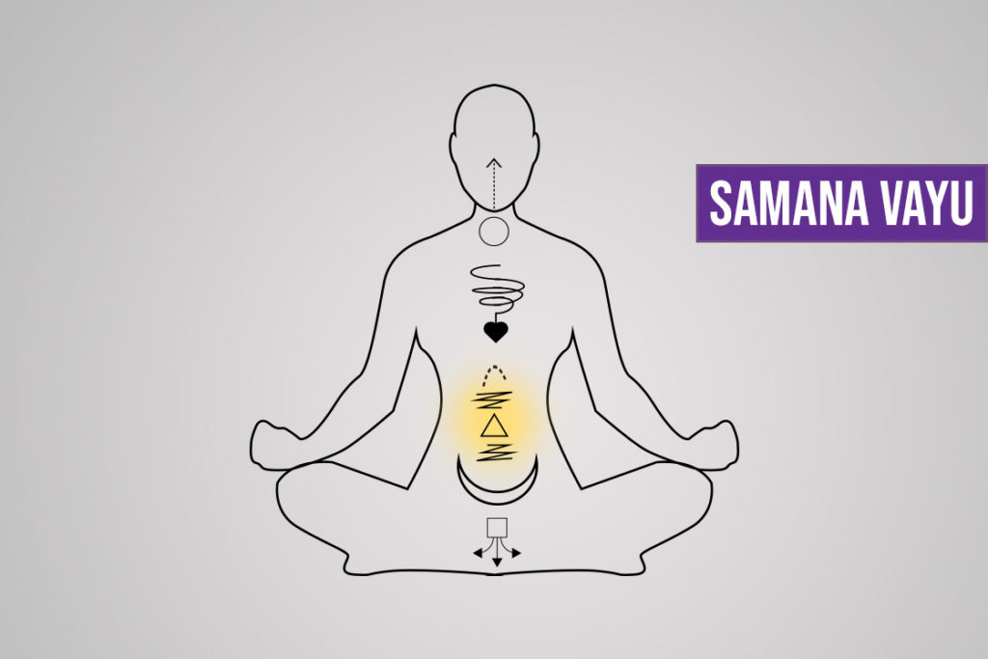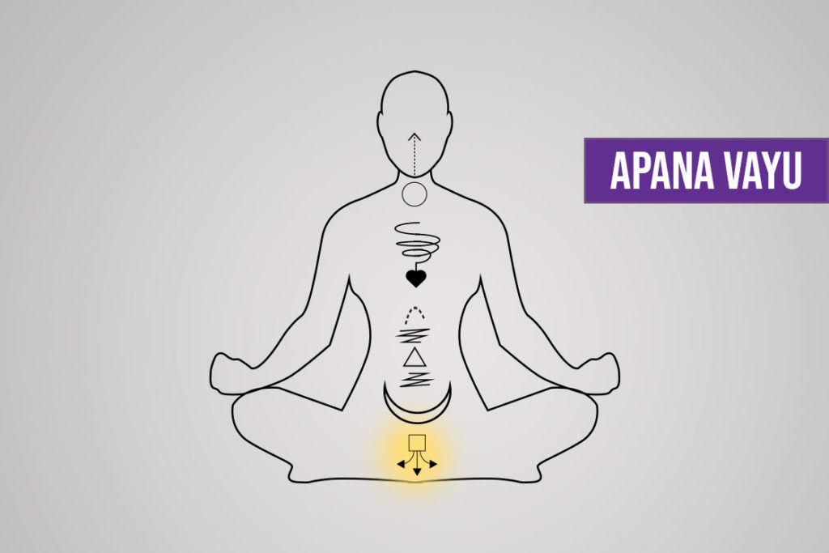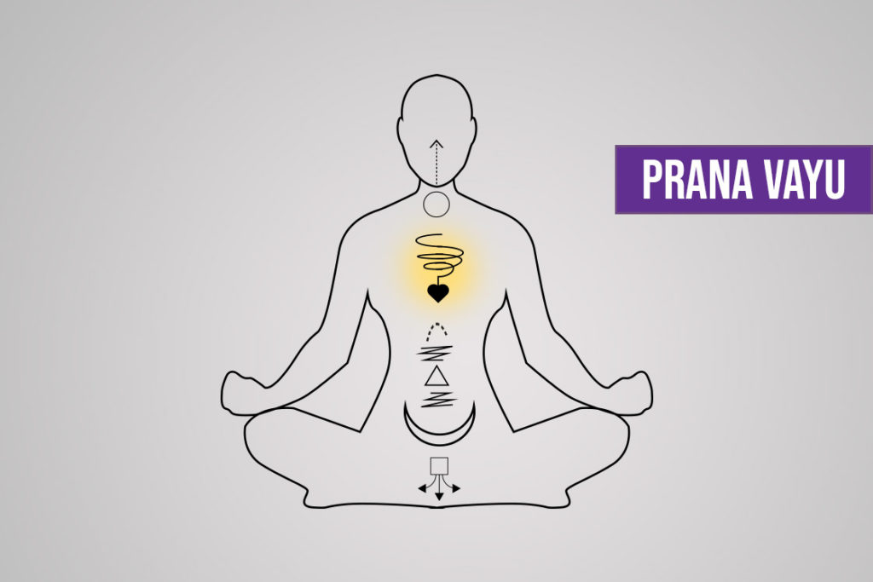

Cakras, Sanskrit translation cakra:- weal of energy.:-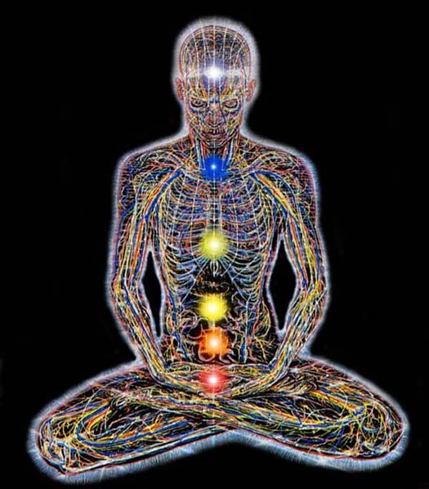
If you take a look to these picture Cakras are circulating energys in weal form. And chakras have a colors. These are big cakras and there is smaller cakras on legs and hands these are elements named in sanscrit and there is lists of cakras they are opening and closing then cakras are working on 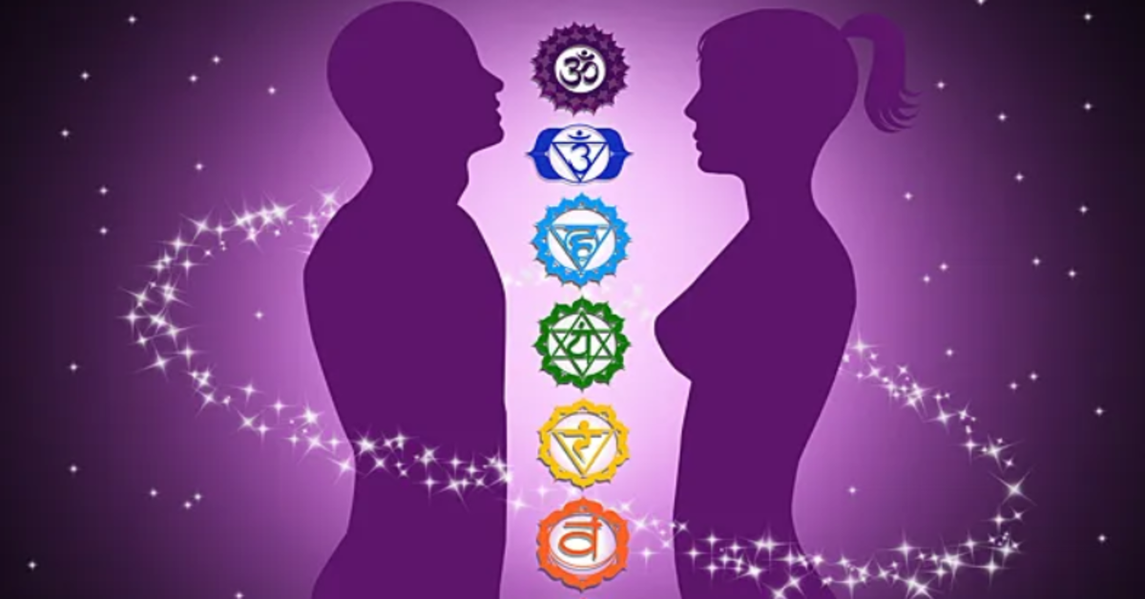
legs fingers 2 lists (on cakras) upwards 3,3on legs,4muladhara,5svadhistana,6manipura,7anahata,8visudha,9adna,1000sahasrara they are opening and clothing the lists in the healing process. Colors becoming whiter bryther and softer with Reiki.
Cakra Reiki 2 diagnose is with Reiki hands of Light (then you turning Reiki on yours hands becoming hands of light and you can connect cakra or fixt with yours hands. When you becoming healthier after Reiki seasions (yours ayes are opening…) you can fix cakras !!(connect broken cakras to major nadis(the ways of energy) yourself and to others) just touch the cakra with yours Reiki on and cakra will connect automatically because yours hands now are hands of light (Light of Reiki).You can connect cakras to nadis to trees ,animals, humans crystals, usual stones. Reiki energy are with wisdom. You can connect broken nadis (ways of light) now with yours hands. Just touch dark with your hands and yours hands will start to accumulate(give) the energy of Reiki. You can now heal with your hands more stronger.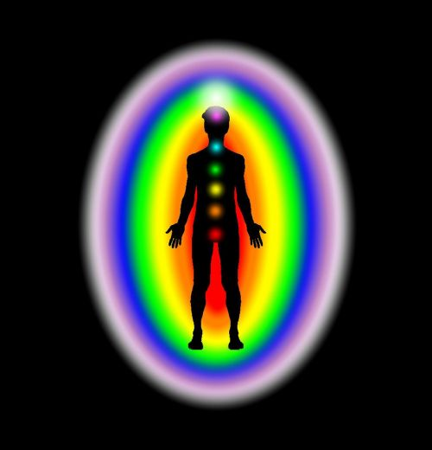
Bio fields have colors as well.
There are 5 major byo fields: vitalic orange, emotional yellow, mental -laith blu, kausal blu, Spiritual purple. Read…this if you have Holy Katekizm big one as well Katekizm is said there you have Angel protector there. You should prey for him. He Asisting you in healing process of Reiki without his permission you should not do Reiki because he is smarter and older, and he belongs for Angels legions of Light His Super Light head is Mixail The king of Archangels and Master of Holy Spirit protection legions of light holy light belongs to him of Holy Spirit. Another Archangel is Gabryel the Archangel of spiritual healing his Divine Light Erarh Gabriel controlling Legions of Angels of light. The archangel Uriel is protector of humans thinking. Raphael is Arhangel Divine Erarx of Light protection of Human Belief system he controlling the legions of Holy Spirit Angels.
Arhangel Ureail Protector of Divine Soul he controlling the divine legions of the angels. Don,t forget to Pray for them.
If you wish to now yours Angel Holy name find it out with Reiki 2 Diagnostic Bio-sen scaning tell the name and check wryte or no and wear the Super Fashion, pashion (The Holy Kryst of yours dreams in this practice) no maney make yourself and after Say on him in process on do Krist sing with hand For the Name of God and Holy Father and Holy sun And Holy Spirit and in the middle amen. And this Holy Kryst you can
youse for your Soul healing. And in the Holy Jesis cryst world it is only Good angels Holy Father Holy Spirit is with you. You have the Hither Reiki self he is assisting you in your Reiki evolution in Reiki Usui Ryoho first, second, third, and fourth the last one degreeses He belongs to the White ray of Divine Light of Spiritual healing and evolution in Reiki
system.

Reiki spaceship:
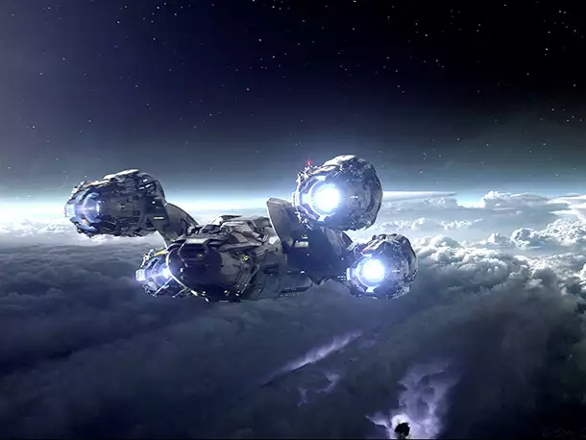

If you ever was thinking about
Reiki space ships is beter to make them from Solar Moduls for akumulation energy in to akumulators (savers of energy) (the picture of Solar system is insaide the book You can make this system for this purpose becose palydovs working with solar energy systems why don,t make Reiki cosmic ship for my self loveable with solar energy system and electric engins of space with Solar system meters (the shower of parameters of your Space ship of Reiki solar energy status…) and don’t forget the ship corpus (of aliuminium)is good for realization to draw pictures of cosmic Reiki ships start from it 4 engines 4 for security don,t forget parachute for the ship end the remount controller of the Yours Reiki ship (radiowave) for yourself end cosmic skafandr for person it,s made of glass and gum and balon of gas for breathing.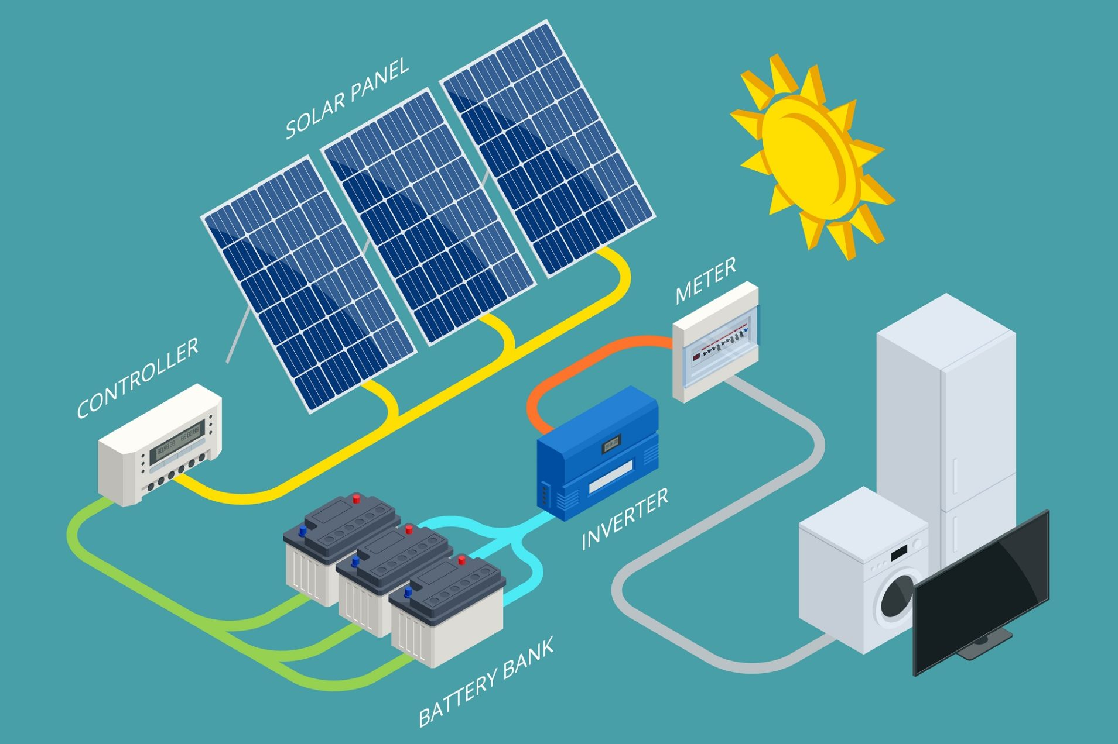
It,s for ship energy for electric engins the food for motors system you mast have the micro wave in the cosmic ship of Reiki freezer and Tv.
And if you decade to do one you need pilot licence for it first.
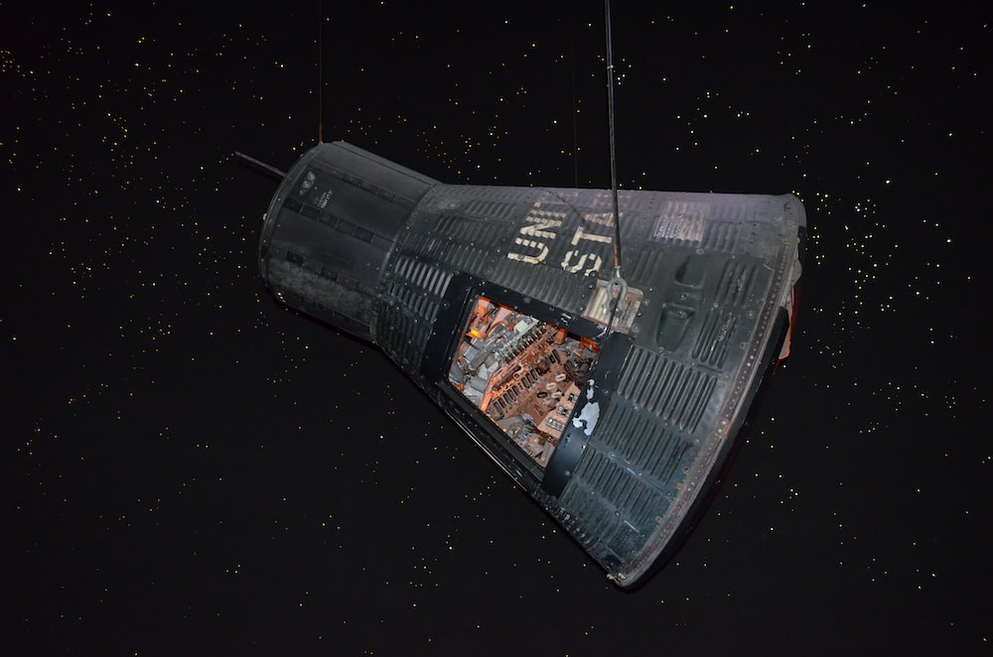
I got the few Initiations of the full session Reiki initiations in Italy from cosmic ships of Reiki in the forests of Italy and cities. You getting Reiki initiations to Usui Ryoho Reiki while you reading these texts and my Donatas Korolis Usui Ryoho Reiki Enlightened Master Teacher help.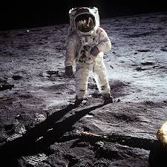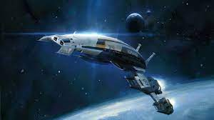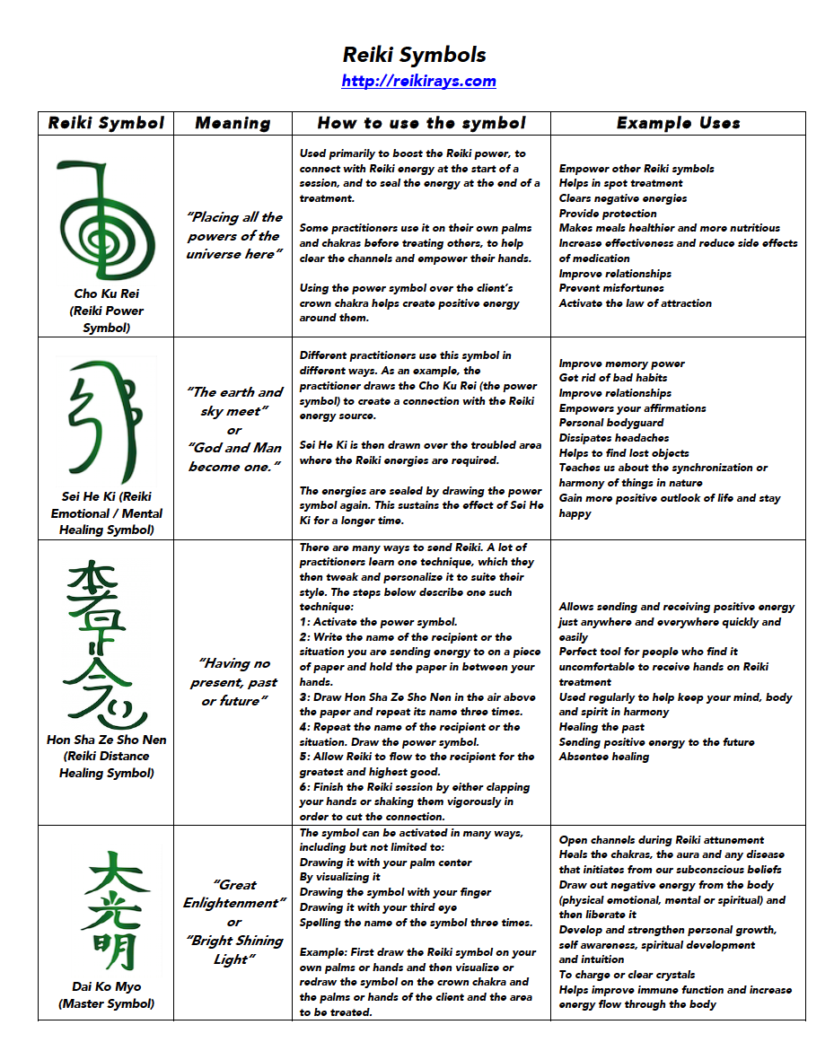
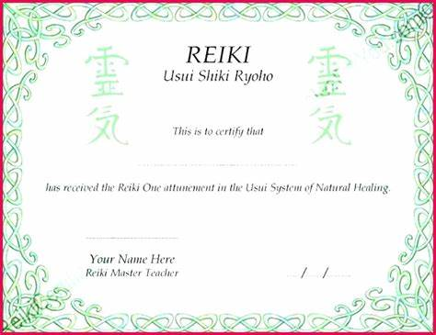
C

